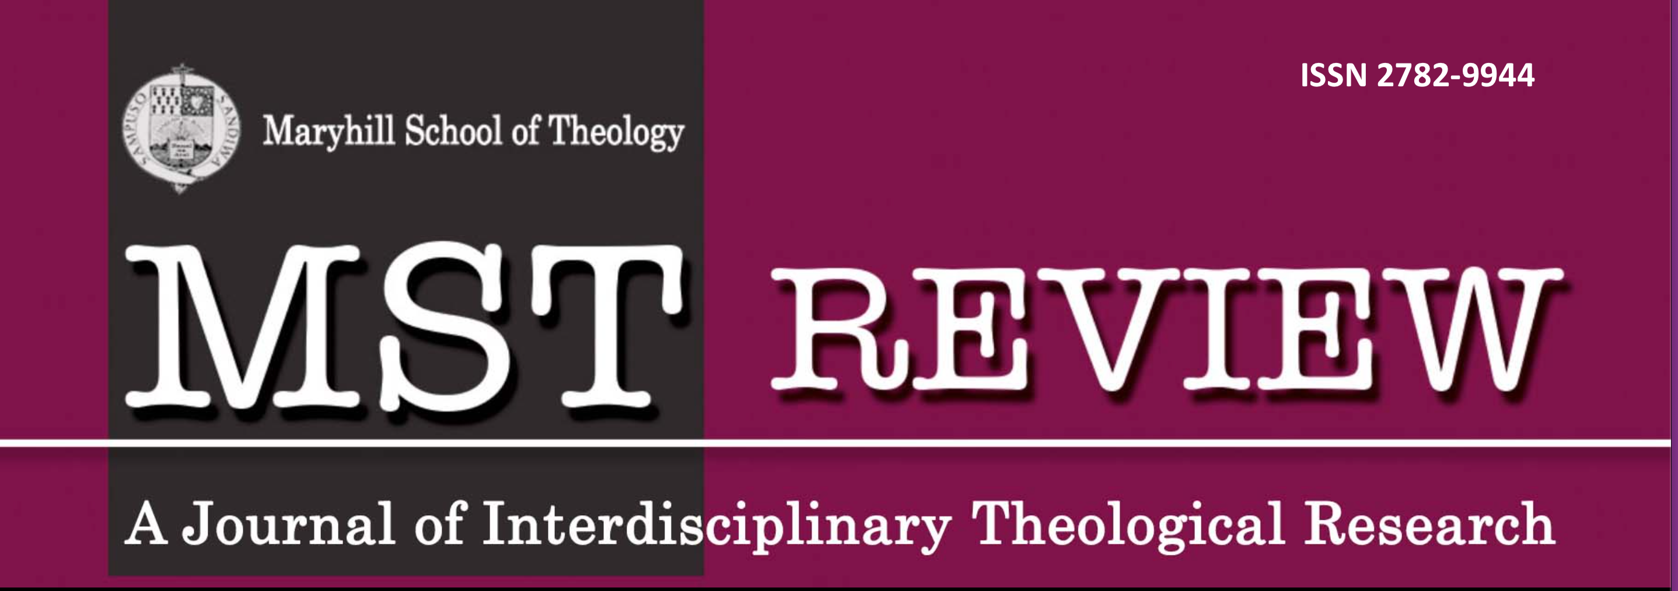
ISSN 2782-9944
n
mstreview.com
Referee's/Reviewer’s email
COPYRIGHT AGREEMENT

MST REVIEW Volume ___ Number ___, Year_____________
Author’s Name: _____________________________________________________________________________________

ORCID _____________________________________________________________________________________

Postal Address: _____________________________________________________________________________________

Email Address: _____________________________________________________________________________________

Phone: _____________________________________________________________________________________

Employer/Institutional Affiliation: _____________________________________________________________________

MANUSCRIPT TITLE:_______________________________________________________________________________

____________________________________________________________________________________________________

____________________________________________________________________________________________________

____________________________________________________________________________________________________

In consideration for the manuscript (above) to be published in the academic journal, MST REVIEW, the undersigned author(s) hereby assign his/her/their copyright interest in the manuscript (above), including its abstract (subsequently referred to as the “work”), to the CICM-Maryhill School of Theology, Quezon City (referred to as “Publisher”) and its successors or assigns effective upon execution of this agreement by the author(s). The Publisher shall have the right to publish the work in any medium and form, or by any means, subject to the following:
- The Publisher claims no other proprietary right other than rights arising from copyright.
- The undersigned Author(s) retains non-exclusive right to revise, adapt, prepare derivative works, present orally, or distribute the work, provided that all such use is for the personal noncommercial benefit of the undersigned and is consistent with any prior contractual agreement between the undersigned and his/her/their employer.
- The undersigned Author(s) is cognizant of the CC BY License . This license allows reusers to distribute, remix, adapt, and build upon the material in any medium or format, so long as attribution is given to the creator(s)/author(s). Not giving credit – or not formatting an attribution properly – violates the license terms, and constitutes copyright infringement. The license allows for commercial use.
- The Author(s) warrants to the Publisher that he/she/they have the right to assign the copyright and that no portion of the copyright to the work has been previously assigned.
- The Author(s) may reprint the work in anthologies or books which are comprised of the Author(s) writings and agrees to notify the Editor and the Publisher of any such reprints of the work.
- Whenever the Publisher is approached by third parties for individual permission to use, reprint or republish the Work, the Publisher will confer with the Author(s) but shall retain the right to grant or withhold permission for such use in its sole discretion.
- The Author(s) agrees to hold harmless and indemnify the Publisher against any claim, demand, suit or action arising from claims of plagiarism, libel, defamation, obscenity, unlawfulness or invasion of privacy or copyright infringement in the Work. The Author(s) shall be responsible for the integrity of the contents of the Work.
- The Publisher shall provide the Author(s) with one (1) complimentary copy of the issue in which the Work appears, and grants the Author(s) permission to reproduce additional copies of the Work.
- In case of on-line publication of the work, the Publisher retains the copyright over the said work.
- The MST Review reserves the right to disseminate information related to your published article in the journal's website and other digital and non-digital platforms.
- All versions of the article (Submitted, Accepted [Author Accepted Manuscript], Published version [Version of Record] are to be deposited in the CICM MARYHILL SCHOOL OF THEOLOGY Library or, in other repository of the author’s choice without embargo.
- It is understood that the Author(s) received no monetary compensation for the assignment of copyright and publication of the Work.
This Agreement contains the entire agreement of the parties and there are no other promises or conditions in any other agreement whether oral or written. This Agreement supersedes any prior written or oral agreements between the parties.
I/We certify that my/our manuscript is an original piece of work. We have properly acknowledged and cited the sources of information and data presented in my/our manuscript.

In witness whereof, I/We have set our hands this ________ day of ______________________, _____________ in _____________________________________. (City, Country)

____________________________________________________
Signature over printed name of Corresponding Author

Conforme:

CICM-Maryhill School of Theology
Publisher

