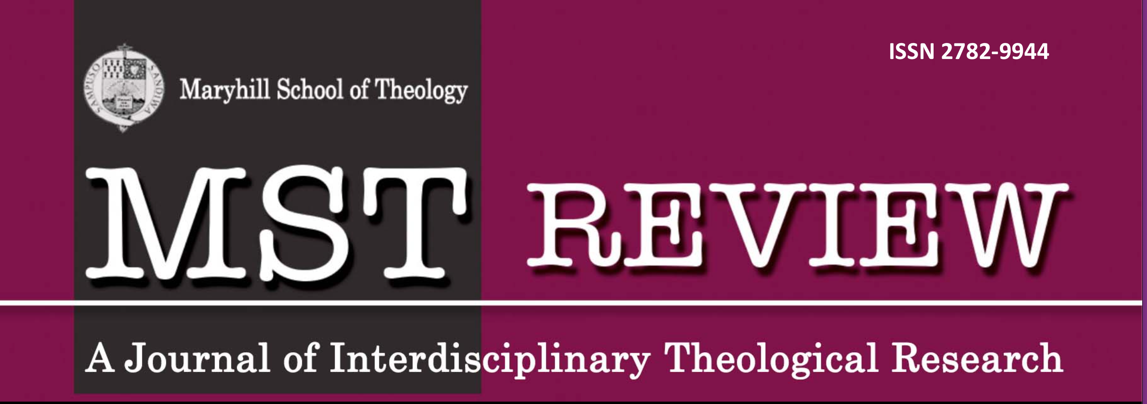
ISSN 2782-9944
n
mstreview.com
Referee's/Reviewer’s email
MANUSCRIPT SUBMISSION FORM

Title
Author/s
Corresponding author
Institutional affiliation/s and address/es
Contact number
Email address
What makes this manuscript fit for publication in
MST Review?

In submitting this manuscript to MST Review, the Author/Corresponding Author declares that:
- the manuscript is original and not duplicated manuscript
- this has not been published previously,
- it is not being submitted for publication in other journals,
- there are no copyright infringements,
- no plagiarism is involved,
- no author has conflict of interests involved,
- (for collaborative works) all co-authors have given consent for the manuscript and its submission to MST Review, and
- a proven violation of any of the above may serve as ground for the journal management to recall an article from publication.

For more information please see the Ethical Guidelines.

___________________________________ ________________________________
Signature of Author/ Corresponding Author Date

